Practical 6
Frequency distribution
- Weights in kilogram of 30 weight lifters are entered in cells A3 to A32. None of these are heavier than 120 kgs Explain the procedure to prepare a frequency table by taking class intervals as, less than 80, 80-90 ,90-100,100-110,110,120

- Heights in centimeter of 40 N.C.C. cadets are entered in cells A3 to A42. None of the cadets are taller than 185 centimeters. Explain the procedure to prepare a frequency table by taking class intervals as, less than 150, 150-160, 160-170, 170-180, 180-186

- Observation lying between 1000 to 9999 have been entered in columns A3 to A42. Write the procedure to prepare a frequency table showing class intervals as upto 1999, 2000-3999, 4000-5999, 6000-7999 and 8000-9999 in cells B45, c45, D45, E45 and F45 and the corresponding frequencies in B46, C46, E46 AND F46 respectively.

- Observation lying between 20 and 69 has been entered in column A3 to A42. Write procedure to prepare a frequency table showing class intervals as 20-29, 30-39, 40-49, 50-59 and 60-69 in cells B45, C45, D45, E45 and F45 and the corresponding frequencies in B46, C46, D46 AND F46 respectively.

Extra problems

- Insurance agent’s name and his total business have been entered in column A and B respectively for 20 agents. First row contains heading next rows contain data. Write steps to compute commission and commission is 5% of the business upto to Rs 1,00,000 and 10% on additional business. Bonus is 2% of business exceeding Rs 5,00,000 only when business exceeds 5,00,00 otherwise it is 0.
- What is an Autofill list? Explain the steps to prepare custom list (custom Autofill) with the values Milk, Butter, Ghee, Cheese, Paneer and display it in cells C1 to C5
- Answer the following
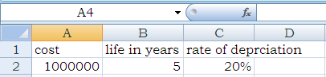
Using straight line method, explain the procedure to display year wise depreciation and depreciated value for each year till the life of Machinery. Use your own cell addresses.

- Consider the following worksheet containing the cost of an Asset, the rate of depreciation and the life of that asset in year. Using reducing balance method explain the procedure to display year-wise depreciation and the W.D.V for each year till the life of the Asset in column, D,E, and F respectively.
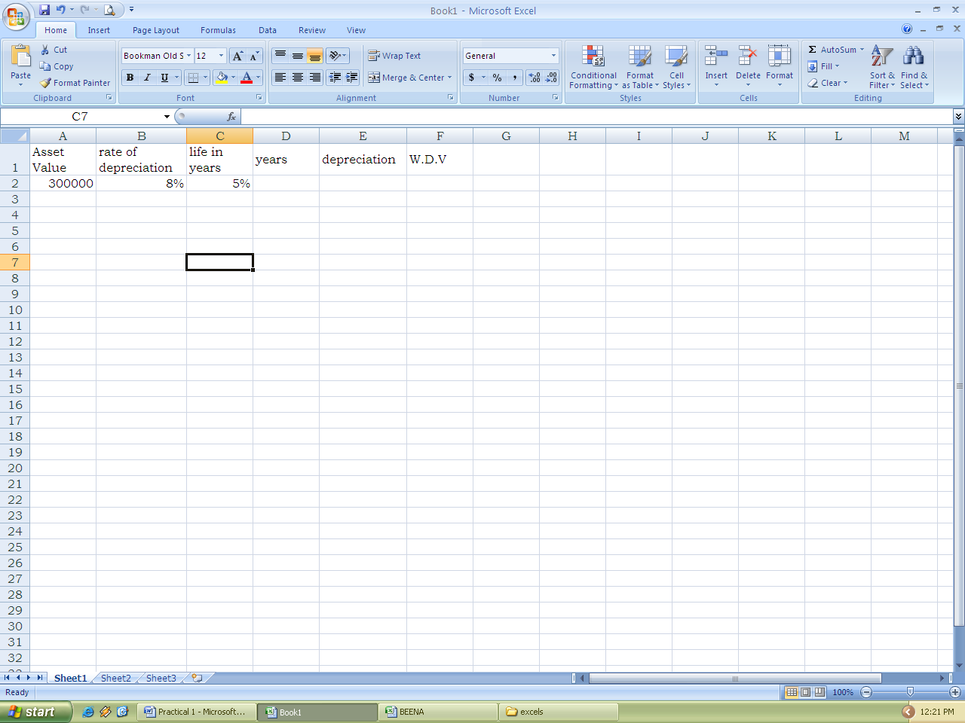
- Answer the following in MS-Excel. The following data has been entered in a worksheet
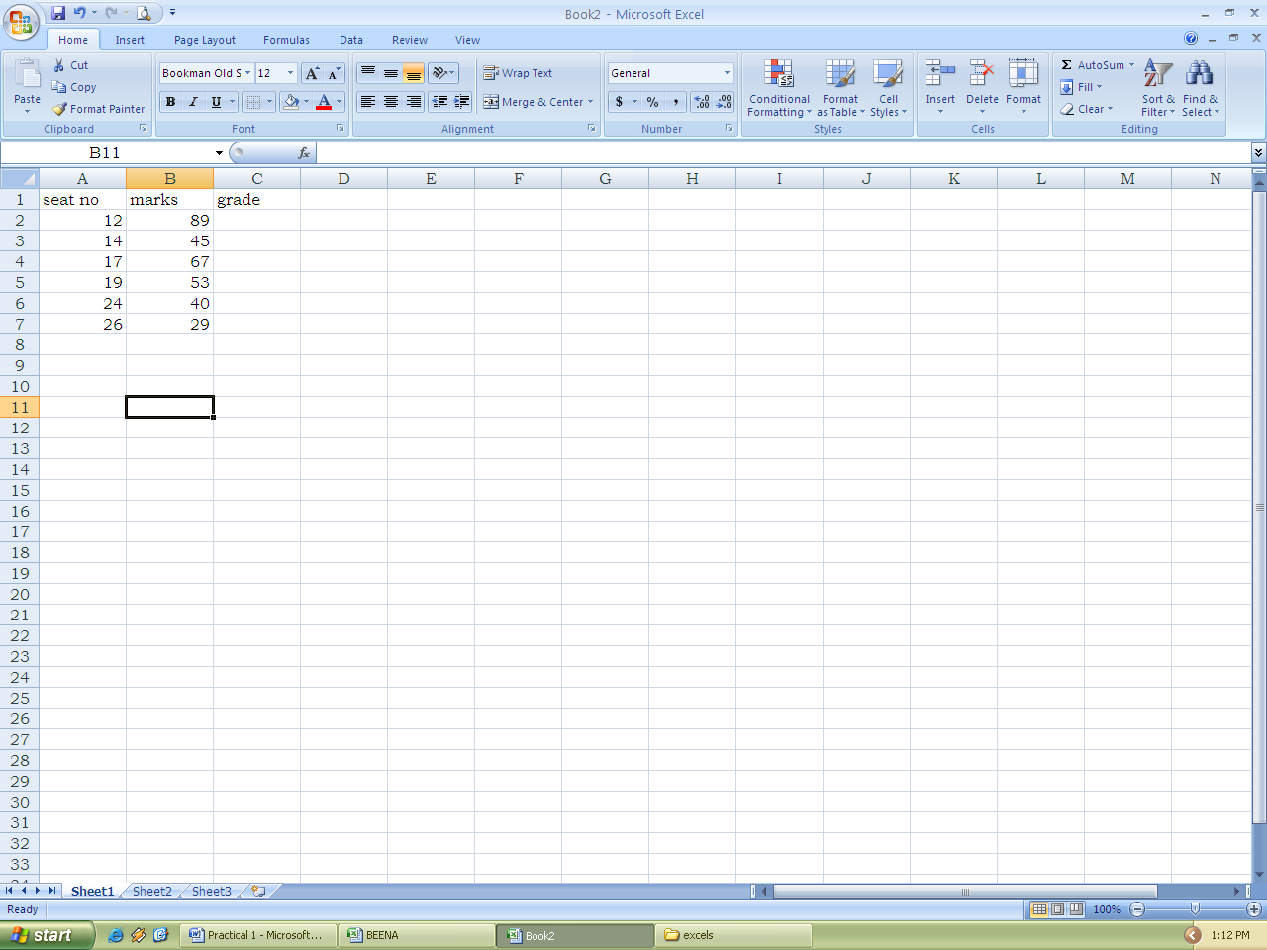
Write steps to compute the GRADE in column C as follows:
Marks Grade
Less than 45 C
45 or more and less than 60 B
60 and above A

- Consider the following worksheet showing cost of machinery and its life in year and rate of depreciation
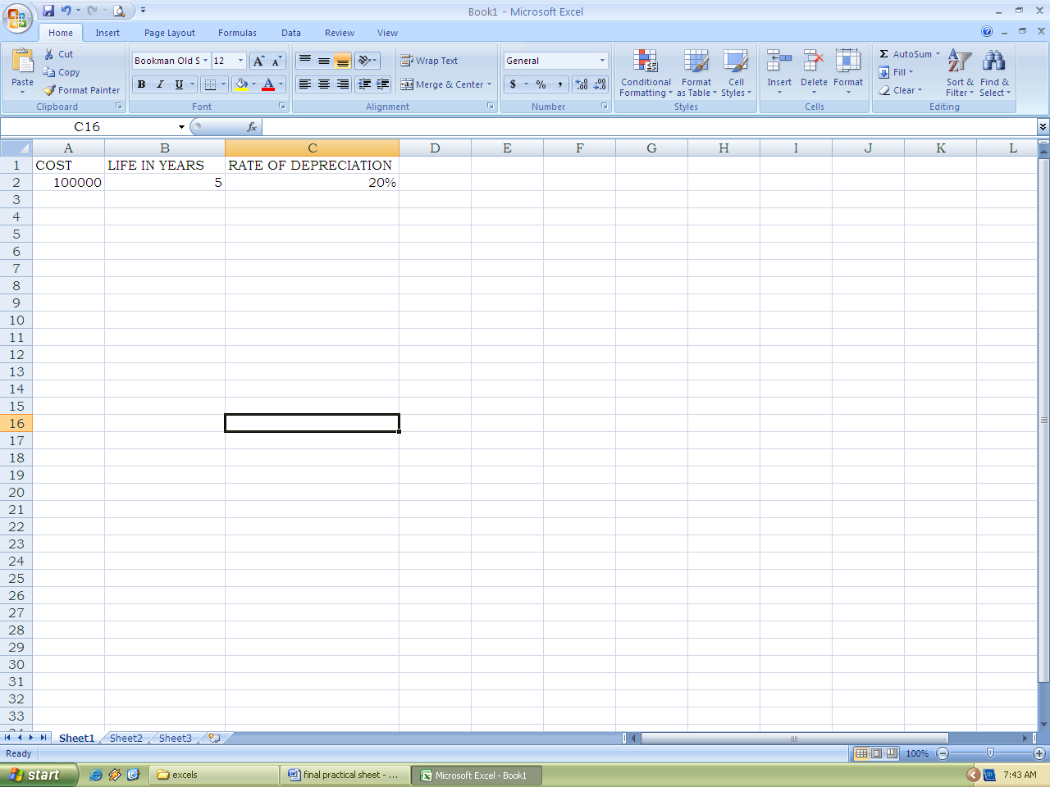

Using straight line method, explain the procedure to display year wise depreciation and depreciated value for each year till the life of Machinery, use your own cell addresses

- A worksheet contain Roll no, and marks out of 100 in 2 subject entered in column A, B, C respectively in first 21 rows. In the first row, heading is entered and in subsequent row data has been entered. Explain the procedure to find average and grade in columns D and E respectively. Grade is to be assigned as follows

Average Grade
75 or more A
50 or more and below 75 B
Below 50 C

- A worksheet contains employee number and monthly gross pay entered in column A and B respectively in the first 16 rows. In first row headings are entered and in remaining rows data is entered. Write steps to compute annual income and income tax in column C and D respectively where income tax is to be calculated as follows:
Annual income Income tax
First 100000 Nil
Next 100000 20%
Excess 30%

- Calculate total, average for the following worksheet
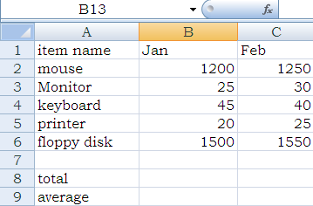
- Answer the following in Ms-Excel
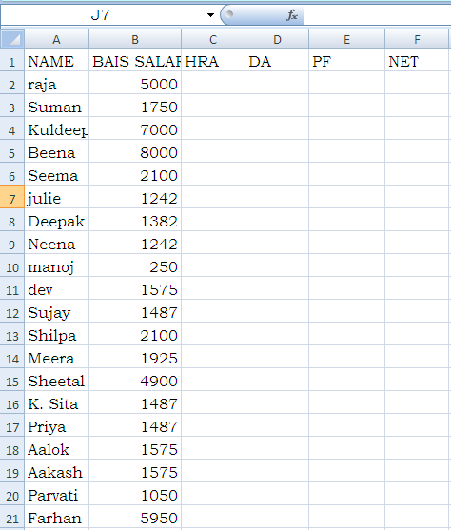
Explain the procedure to calculate (i) HRA as 20% of BASIC (ii) DA as 25% of BASIC (iii) Pf as 5% of BASIC (iv) Net as BASIC+HRA+DA-PF. Fill the entire worksheet.

- The following data has been entered in a worksheet
Explain the procedure to compute AVERAGE MARKS and grade as per the following criteria fill the entire cell
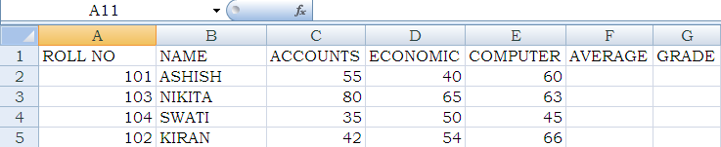
Average Grade
>=75 DISTINCTION
<75 BUT >=60 FIRST CLASS
<60 BUT >=45 SECOND CLASS
<45 BUT >=35 PASS CLASS
<35 FAIL
- The following data has been entered in a worksheet
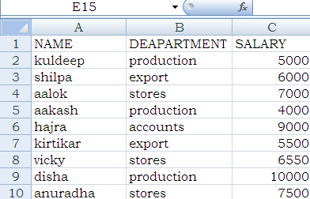
Write the steps to (i) arrange the data as per salary (ii) display only those names where names start with “k”

- The following data has been entered in a worksheet
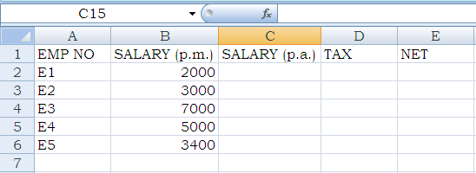
Write the steps to do the following using paste special
- Compute annual salary in the cell C2 to C6
- Compute tax as 20% of the annual salary in the cell D2 to D6
- Compute Net in cells E2 to E6

- Value of an article is entered in cell A3, rate of depreciation is entered in cell B3. Explain how you will create an excel table showing year, depreciation amount, depreciated value. Use reducing balance method.

- The following Data has been entered in a worksheet.
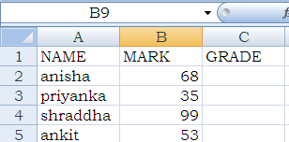
In a cell C2 , a formula , =IF(B2<40, “C”,IF(B2<60, “B”, “A”)) is entered and this formula is copied to C3, C4 and C5. What will be exhibited in cells C2, C3, C4 and C5?

- The following data has been entered in a worksheet
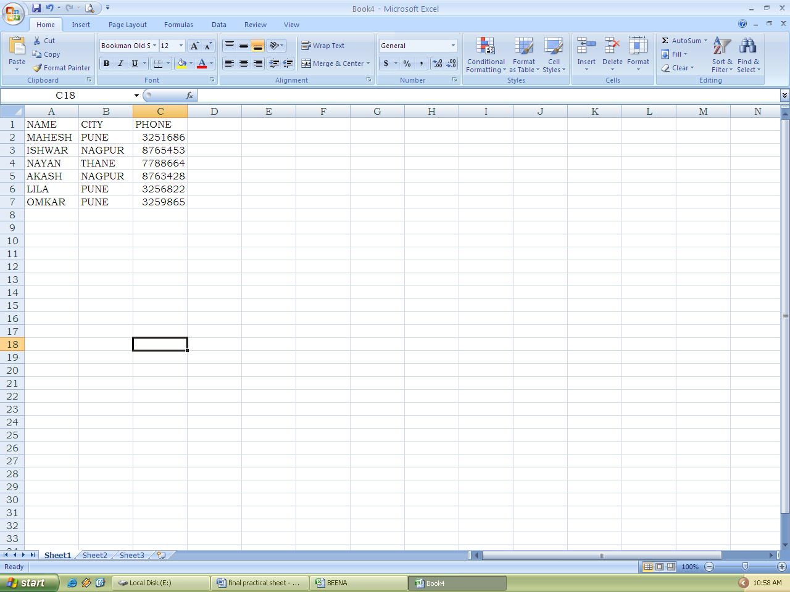
Write procedure to reorganize the worksheet in the order of cities NAGPUR, PUNE and THANE and in cities in the alphabetical order of name

- The following data has been entered in a worksheet
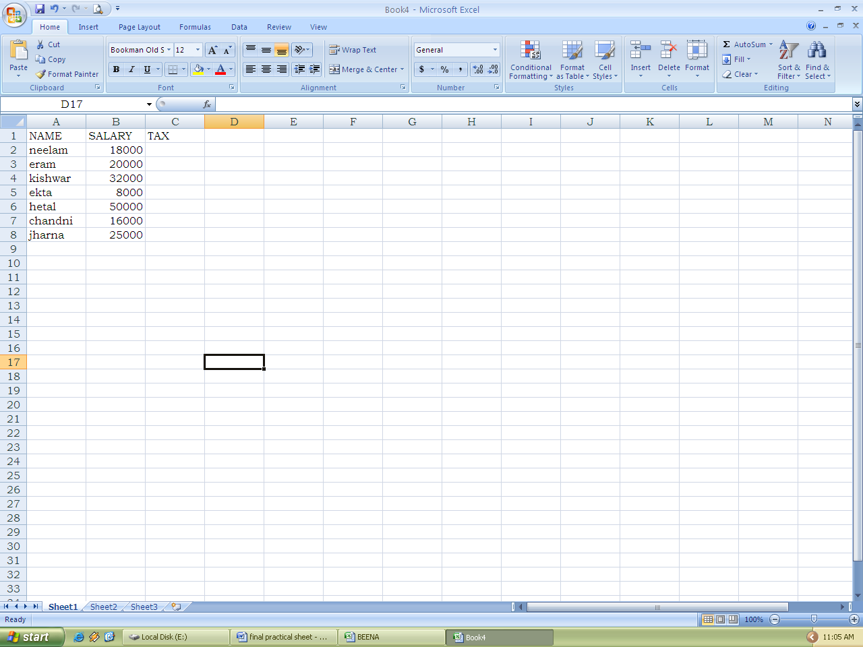
Write a formula in cell C2 to calculate tax as follows
SALES TAX
First Rs 10000 5%
NEXT 15000 8%
Excess 10%
- The following data has been entered in a worksheet
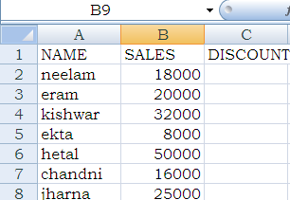
Write a formula in cell C2 to calculate discount as follows:
SALES DISCOUNT
First 10000 5%
Above Rs 10000 and upto Rs 25000 8%
Above Rs 25000 and upto Rs 40000 10%
Above Rs 40000 12%

- Consider the following worksheet showing the Basic salary of 7 person
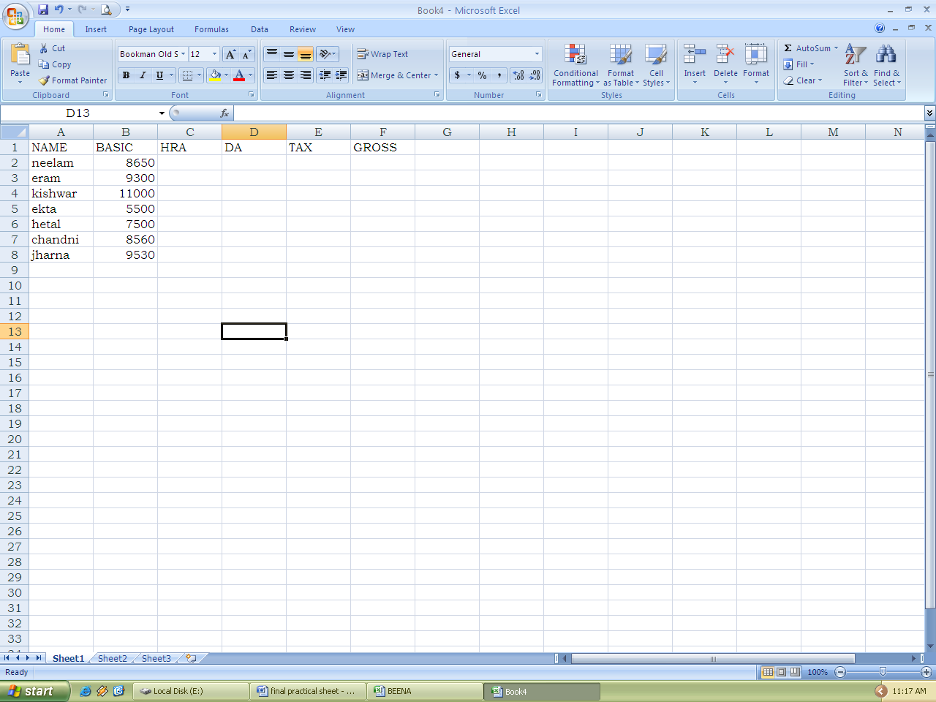
Mention steps for writing the formulae to compute the following
- HRA is 30% of basic salary
- DA as 110% of basic salary
- Tax as 20% of Gross

